VIEW FUEL PRICE HISTORY

PURPOSE:

This procedure is a step by step guide on how to view the submitted fuel price history for fuel types sold at your service station.

AUDIENCE:

All fuel outlet Managers and Operators who are registered in the MyFuel NT system.

STEP 1
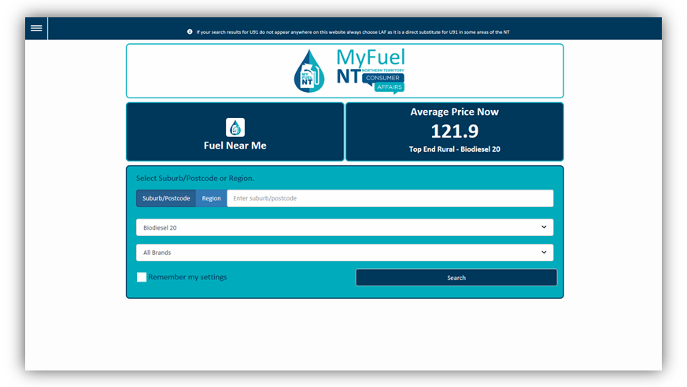

Go to the MyFuel NT website at https://myfuelnt.nt.gov.au.

The MyFuel NT home page is displayed.

STEP 2
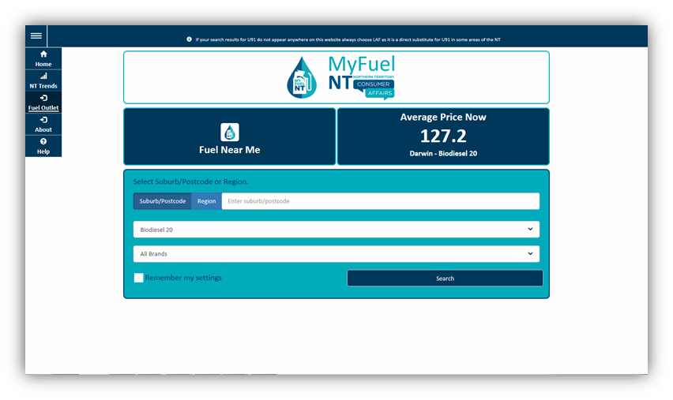

Navigate to the top left of the screen click the main menu and a drop down menu will appear, select ‘Fuel Outlet’.

Step 3

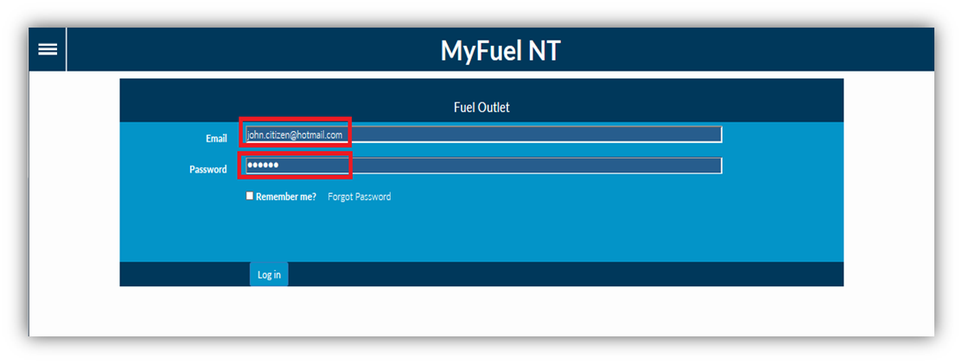

Enter your email address in the ‘Email’ field. Enter your password in the ‘Password’ field.
Check the ‘Remember me?’ checkbox if you prefer your details to be stored for your next login. Click on the ‘Log in’ button.

Step 4
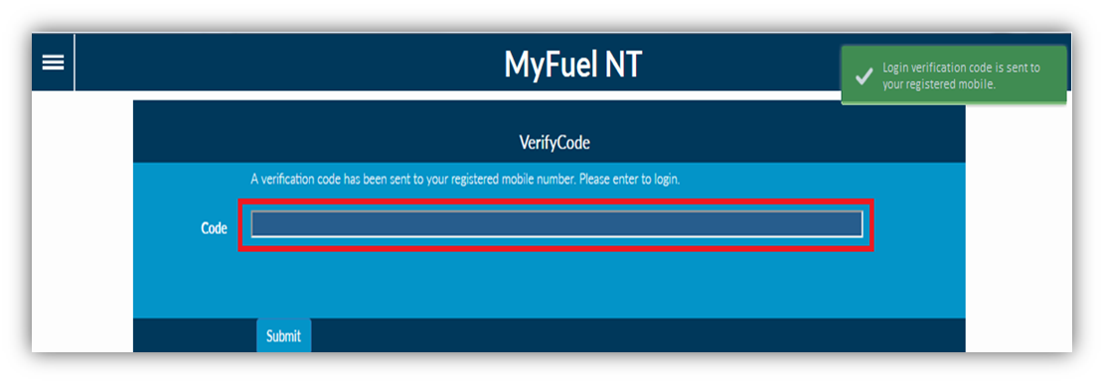

The Verification Code page is displayed.

The verification code will be sent to your registered mobile number. *
Enter the verification code in the ‘Code’ field. Click on ‘Submit’ button.

- If you do not have a mobile telephone, you will need to contact NT Consumer Affairs for assistance on telephone number: 1800 019 319 or 08 8999 1999 .

Step 5

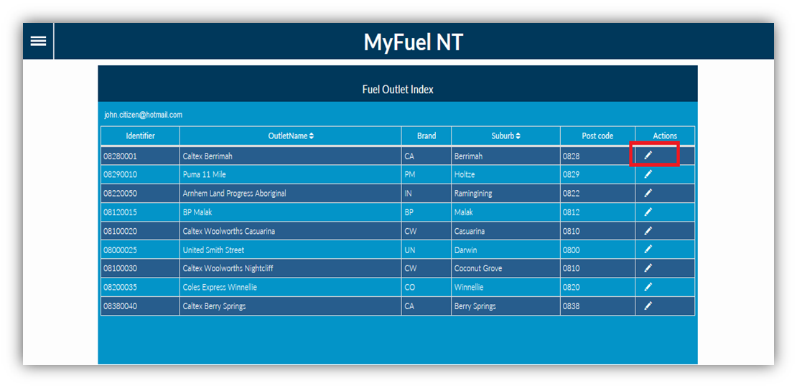

You will be presented with the Fuel Outlet Index page.

All service stations that you manage or are an operator at, will appear on the list. Click on the ‘Edit Fuel Outlet’ button in the Actions column.

Step 6

The Fuel Outlet Administration page will be displayed.

Managers are presented with the following options:

  - Submit Fuel Price
  - Price History
  - Fuel Outlet Details
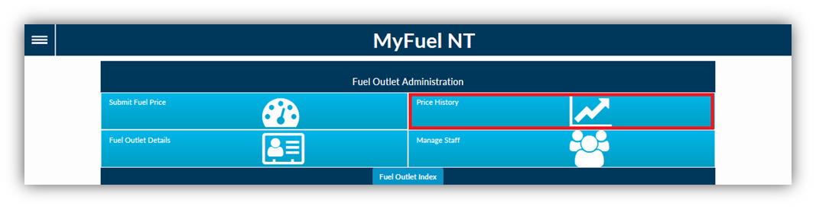
  - Manage Staff
Operators are presented with the following options:

  - Submit Fuel Price
  - Price History

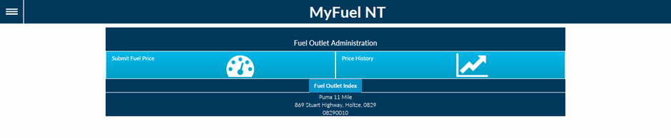

Both Managers and Operators should select ‘Price History’.

Step 7
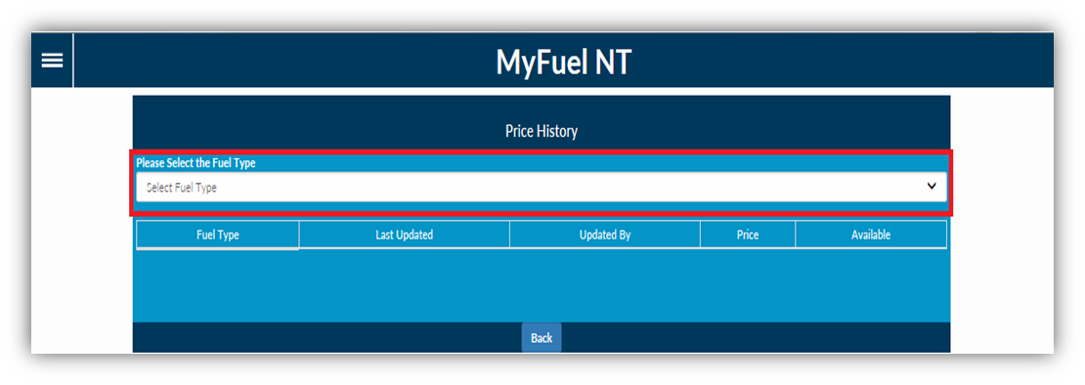

You will be presented with the Price History Page.

Click on the ‘Select Fuel Type’ dropdown list to view all available fuel types.

STEP 8
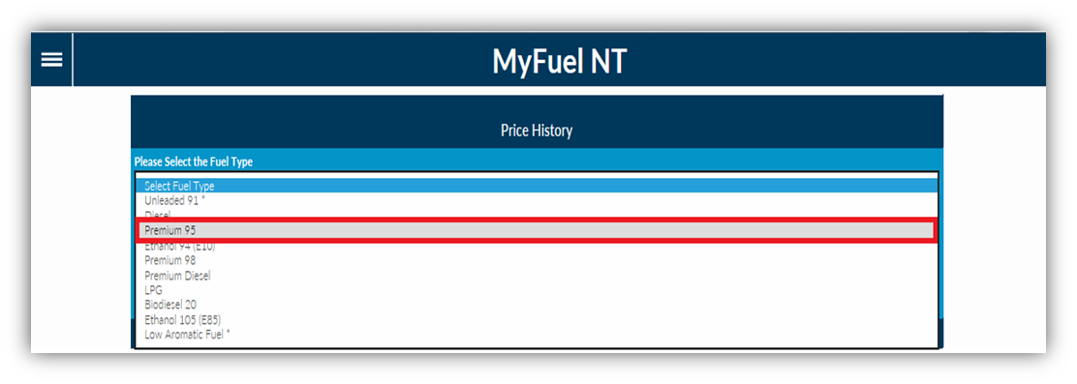

A list of all available fuel types will be displayed.

Select the fuel type you want to view the history of by clicking on it.

STEP 9
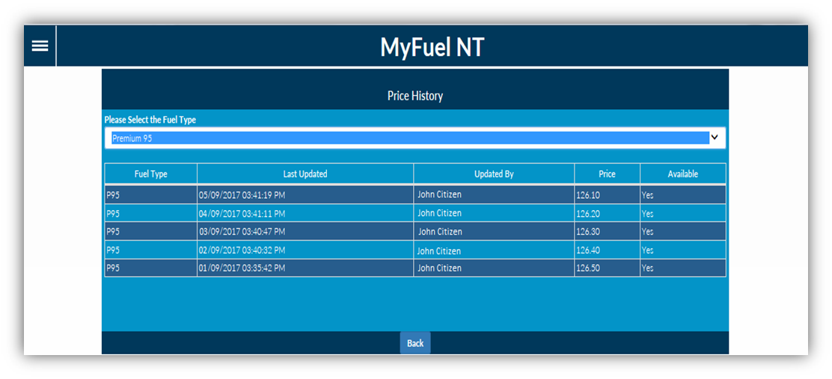

All changes in the fuel prices for the selected fuel type will be displayed. Click on the ‘Back’ button to return to the Fuel Outlet Administration Page.

