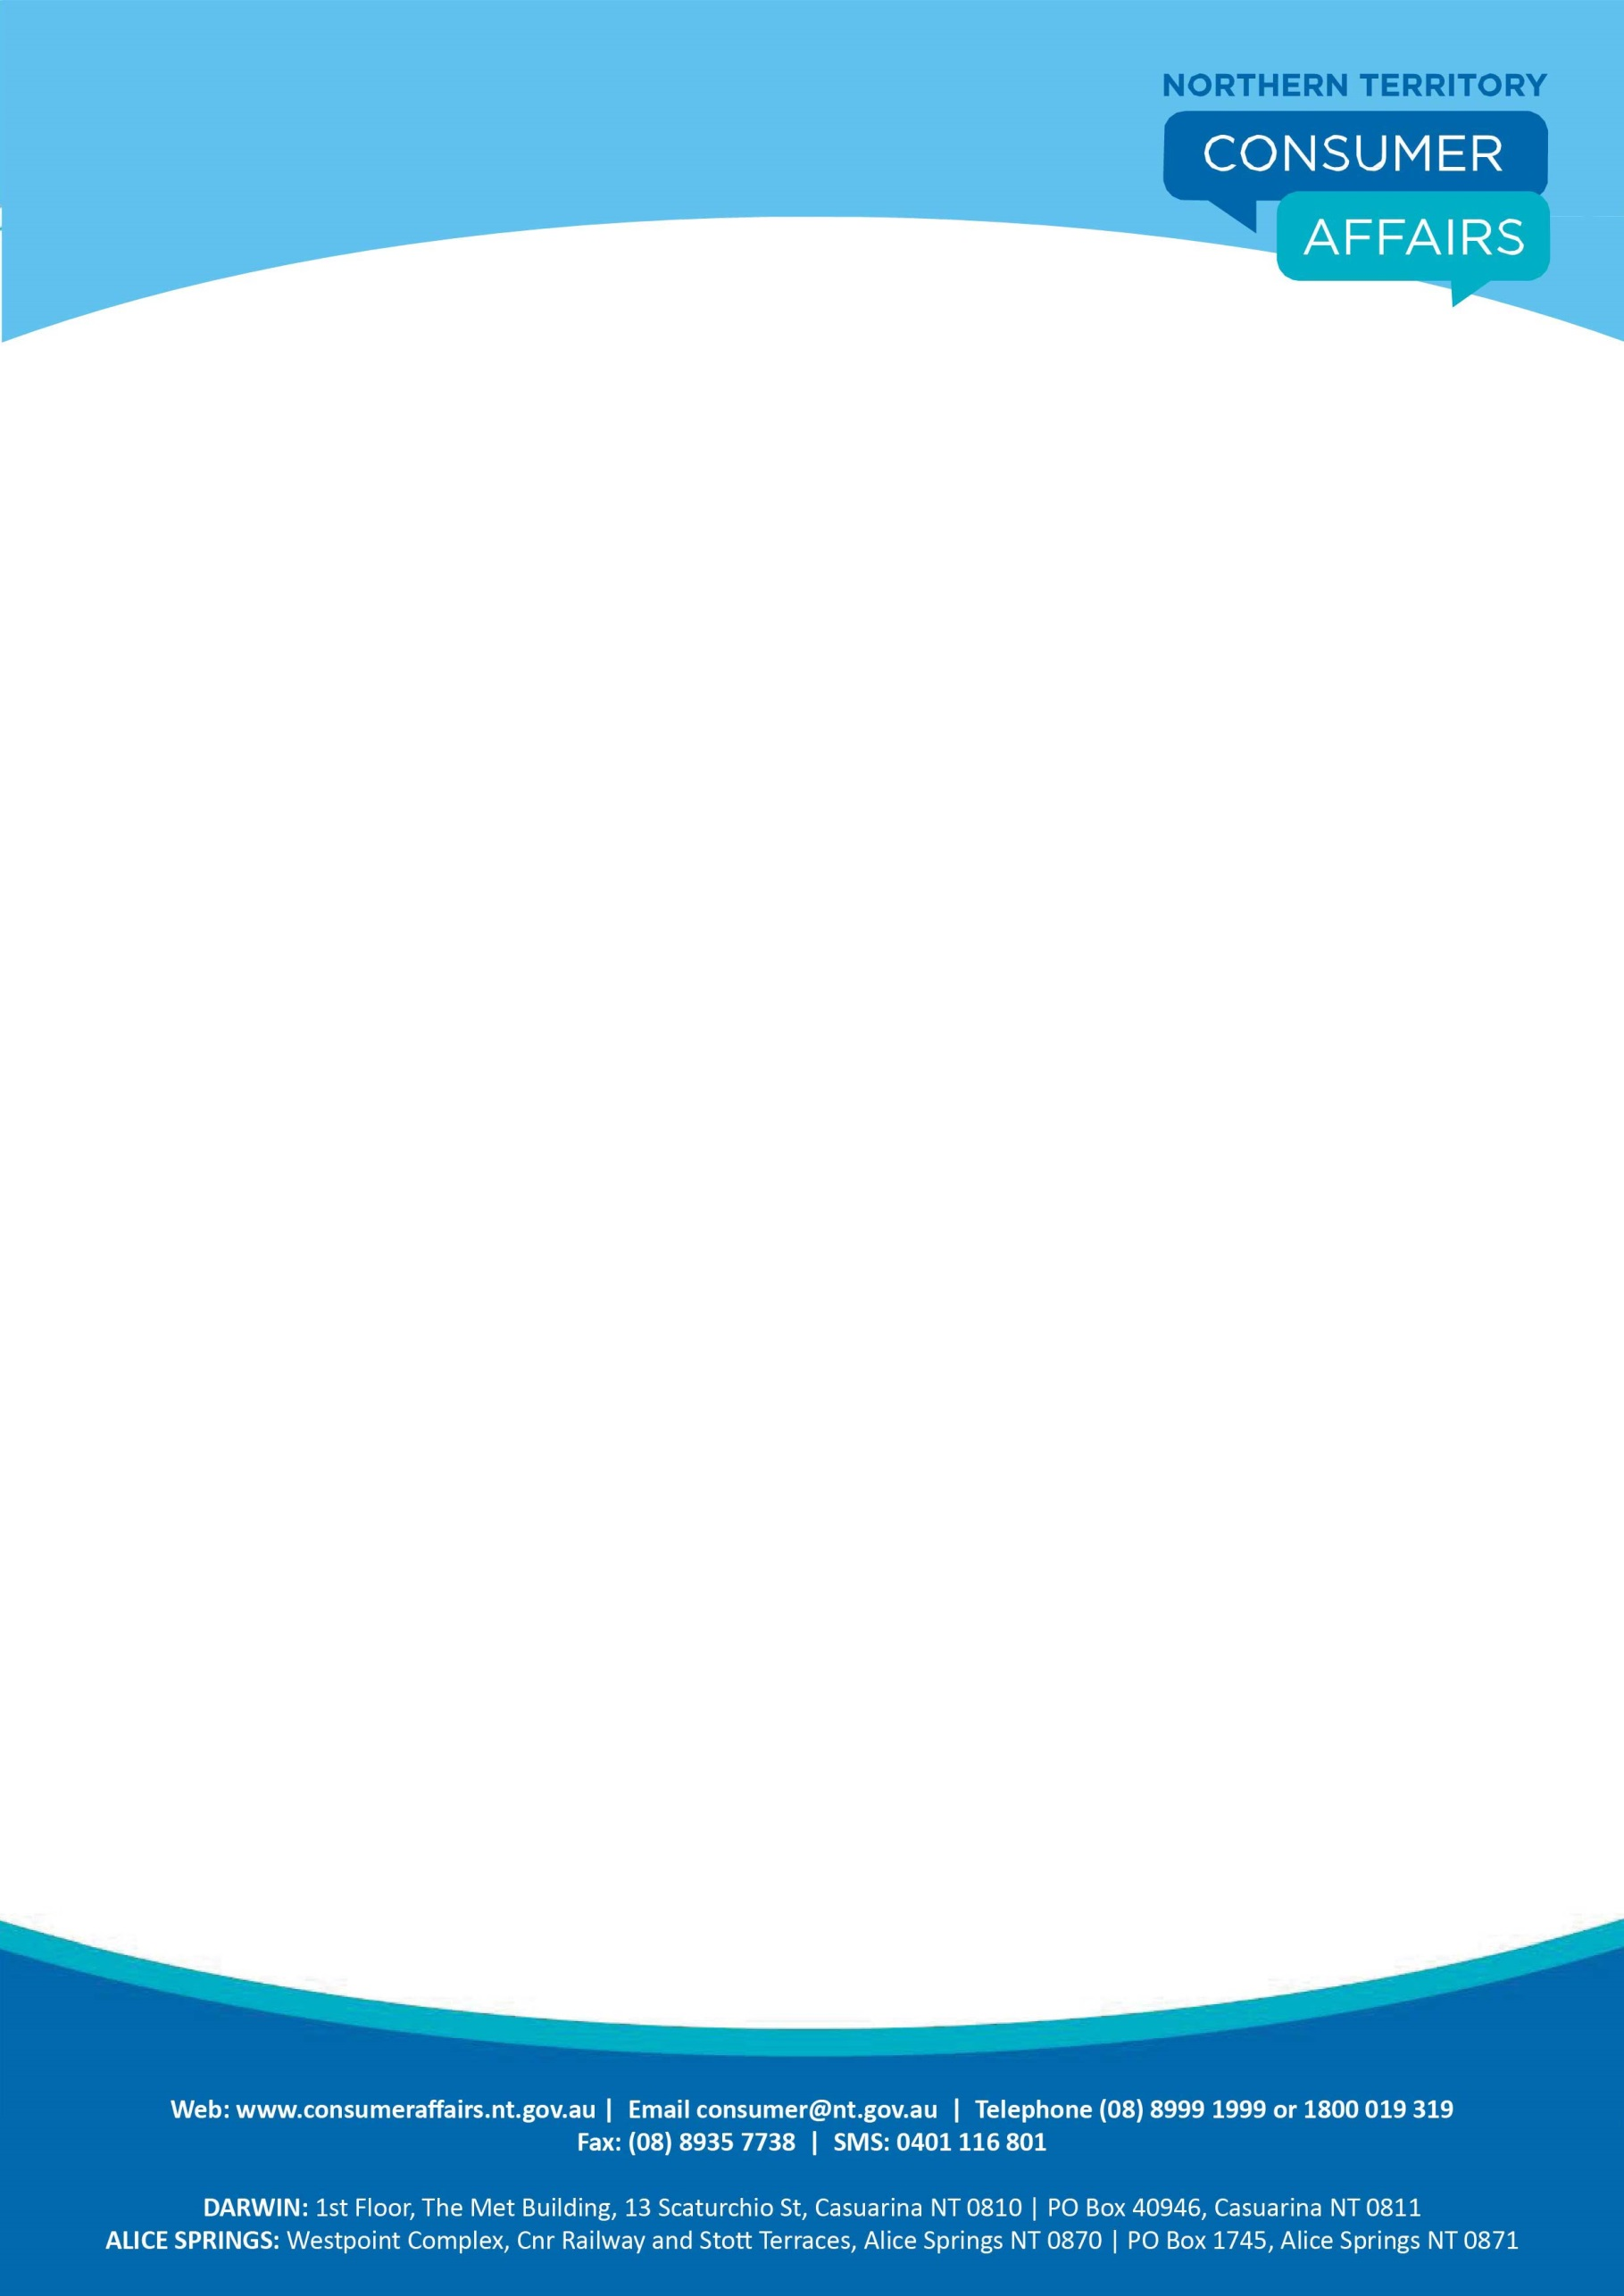

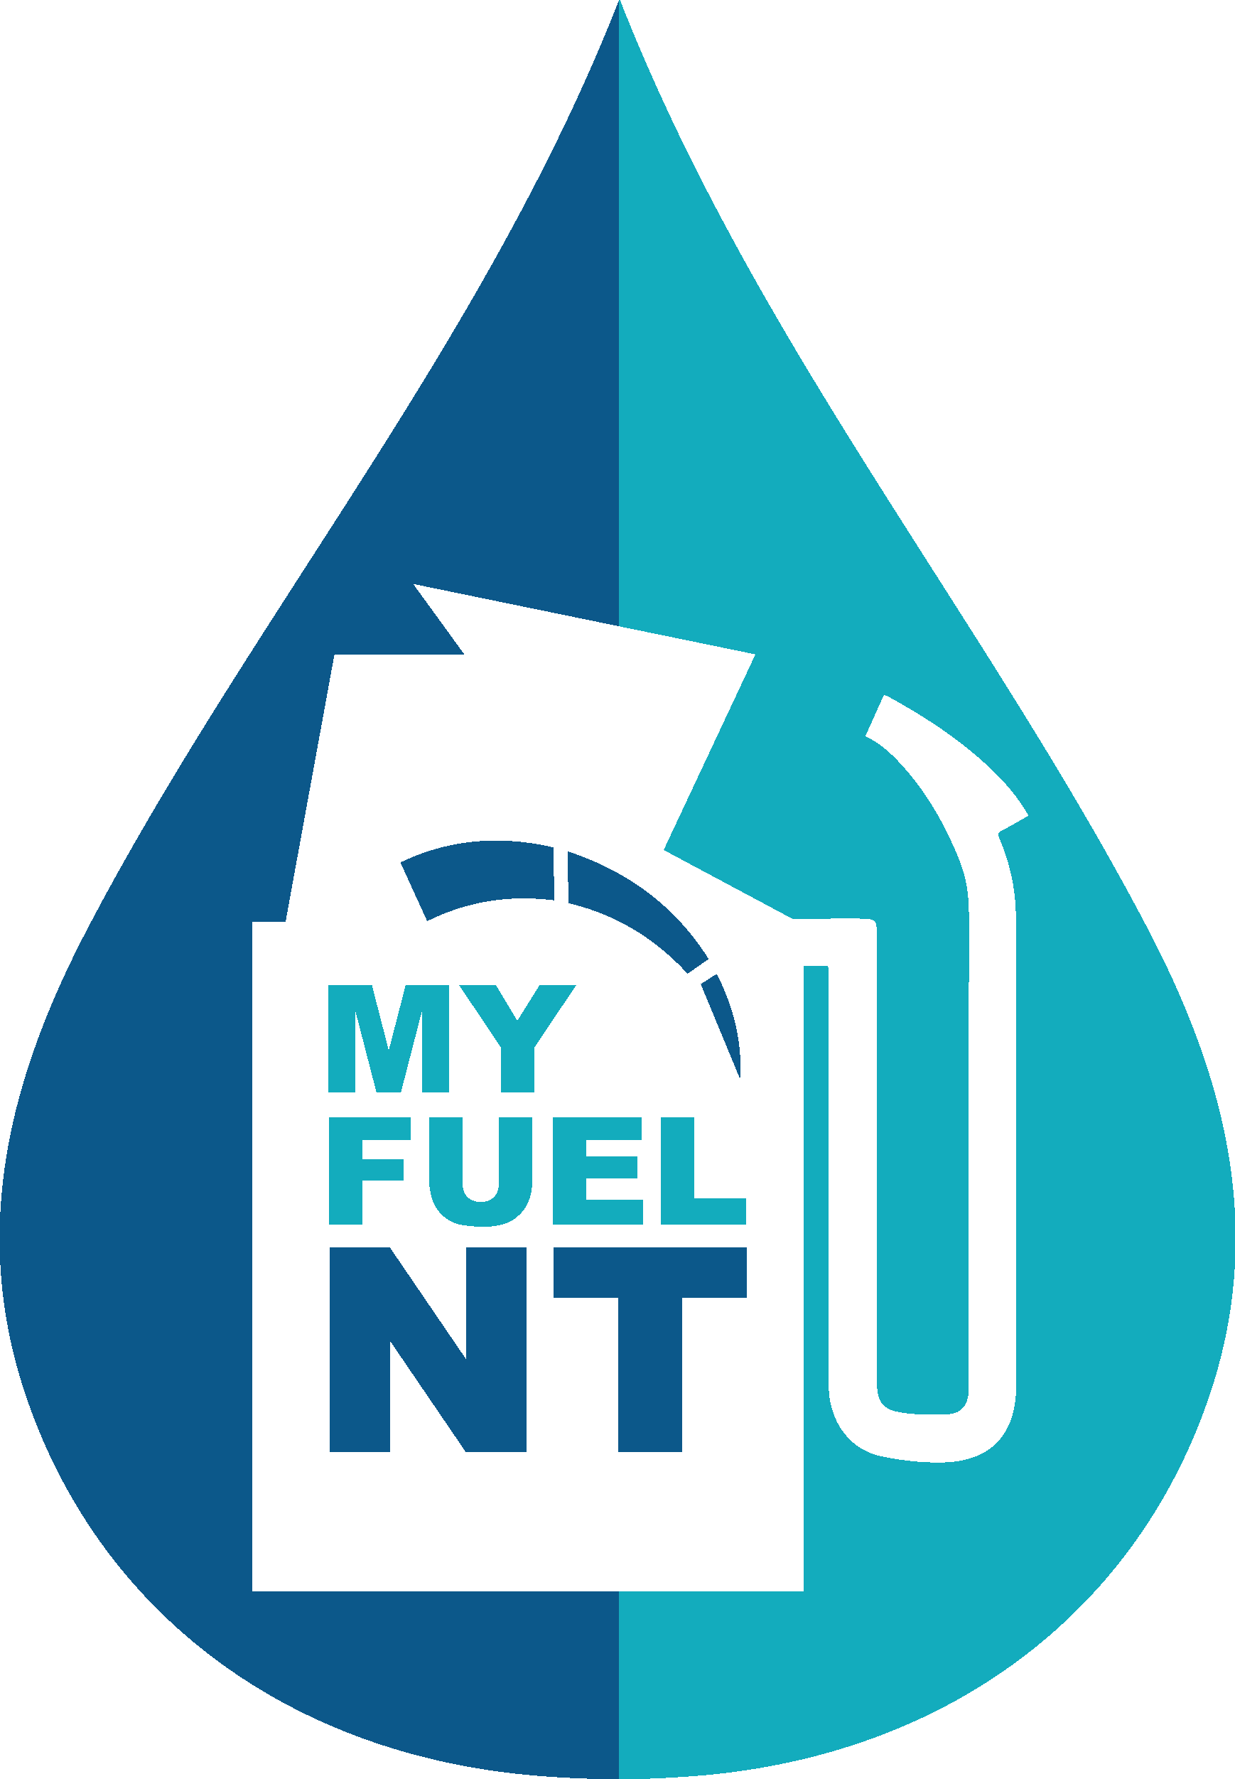

**Fuel Price Discrepancy Report Form**

To report a MyFuel NT ‘Price Mismatch’ or fuel availability discrepancy, complete the form below.

You will need to include evidence (either a photo showing the advertised fuel price at the service station, or a copy of your receipt) to verify the price of the fuel at the exact time you were at the service station.

Please note that **all** fields marked **\*** must be completed.

|  |
| --- |
| 1. **Price Discrepancy Details \*** |
| Service Station Name:  As shown on MyFuel NT |
| Service Station Address:  As shown on MyFuel NT |
| Date: |
| Time: |
| Type of Fuel: |
| Advertised/signage price in cents (ie 127.5):  or n/a if fuel not available at the service station |
| MyFuel NT price in cents (ie 126.5): or n/a as shown on MyFuel NT (as applicable) |

|  |
| --- |
| **2. Your Details \*** |
| Please tick:  Mr  Mrs  Ms  Miss  Other |
| Surname: Given name(s): |
| Postcode: |
| Email address: |
| Business phone: Home phone: |
| Mobile: Fax: |



|  |
| --- |
| **3. Supporting Evidence \*** |
| Supporting evidence included with the report.  Fuel Receipt:  Fuel pump price image:  Price Board image: |

|  |
| --- |
| **4. Discrepancy Details** |
| If you wish to provide more information you may write a brief summary outlining the details of the Price Discrepancy. |

Once you have completed all the fields submit the form to NT Consumer Affairs along with your supporting documentation to:

Email: [consumer@nt.gov.au](mailto:consumer@nt.gov.au)

Fax: (08) 8935 7738

Post: NT Consumer Affairs

PO Box 40946

CASUARINA NT 0811

In Person: First Floor

The MET Building

13 Scaturchio Street

Casuarina NT 0812

Ground Floor

Green Well Building

50 Bath Street

Alice SPRINGS NT 0870