UPDATE FUEL OUTLET DETAILS

PURPOSE:

This procedure is a step by step guide on how to update the service station contact details and fuel types offered for retail sale

AUDIENCE:

All fuel outlet Managers who are registered in the MyFuel NT system.

STEP 1
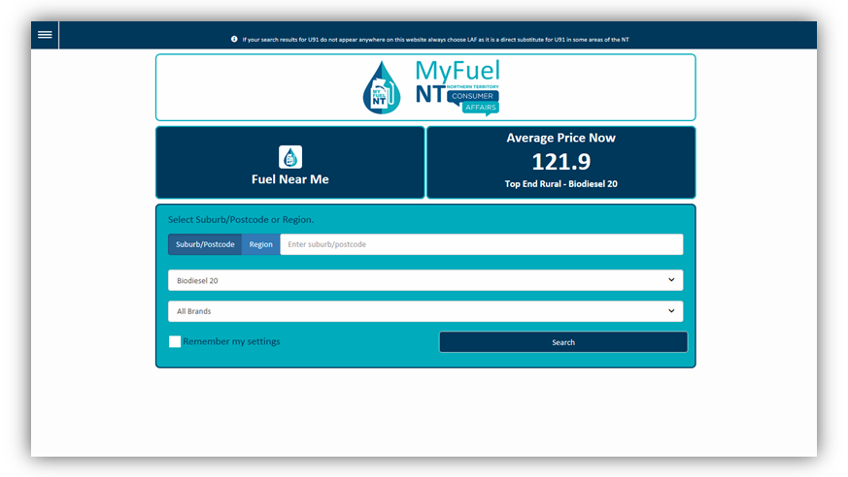

Go to the MyFuel NT website at https://myfuelnt.nt.gov.au.

The MyFuel NT home page is displayed.

STEP 2
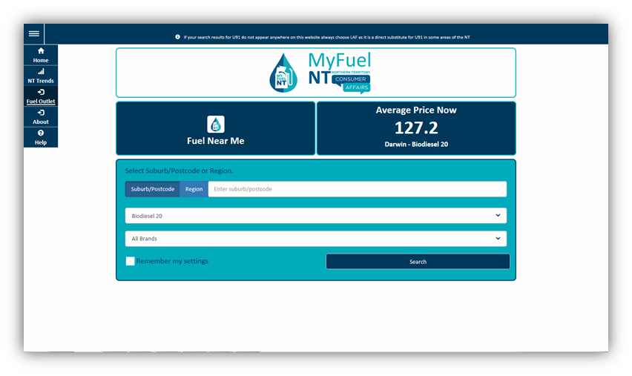

Navigate to the top left of the screen click the main menu and a drop down menu will appear, select ‘Fuel Outlet’.

Step 3
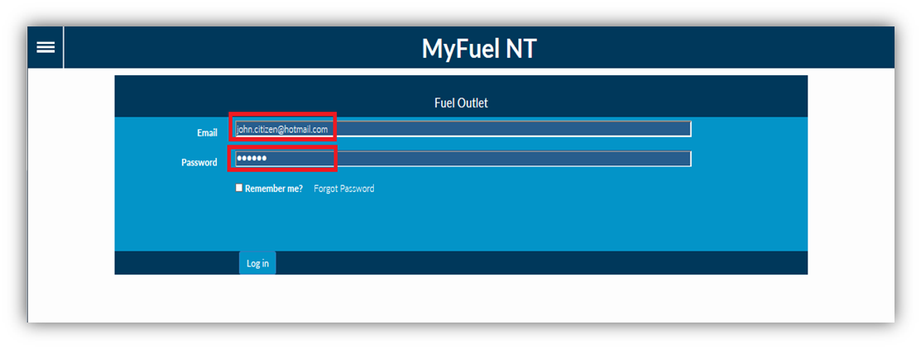
Enter your email address in the ‘Email’ field. Enter your password in the ‘Password’ field.
Check the ‘Remember me?’ checkbox if you prefer your details to be stored for your next login. Click on the ‘Log in’ button.

Step 4
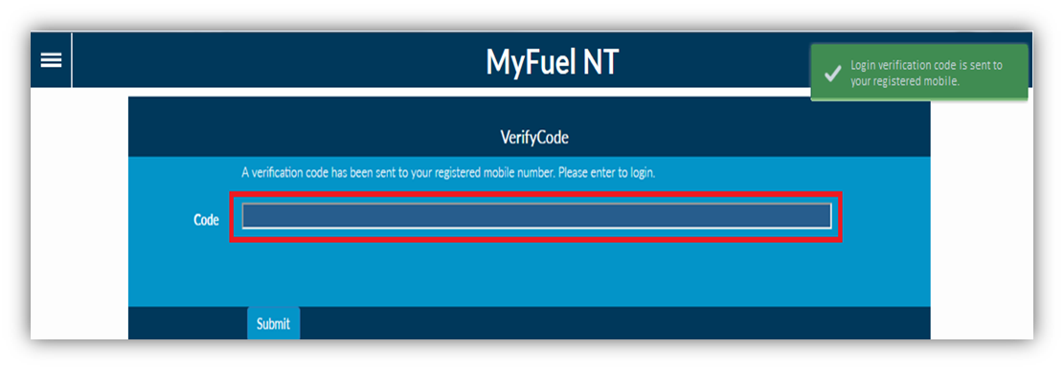

The Verification Code page is displayed.

The verification code will be sent to your registered mobile number. *
Enter the verification code in the ‘Code’ field. Click on the ‘Submit’ button.

- If you do not have a mobile telephone, you will need to contact NT Consumer Affairs for assistance on telephone number: 1800 019 319 or 08 8999 1999.

Step 5

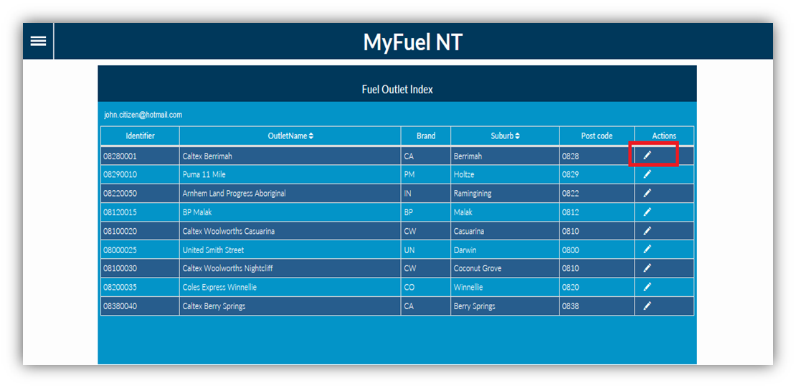

You will be presented with the Fuel Outlet Index page.

All service stations under your management will appear on the list. Click on the ‘Edit Fuel Outlet’ button in the Actions column.

Step 6
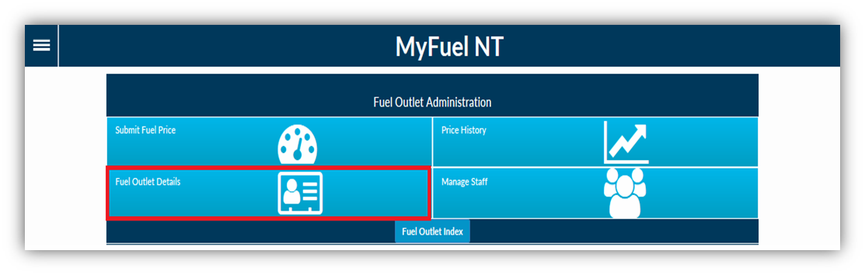
The Fuel Outlet Administration page will be displayed.

As a Manager, the following options are available to you:

  - Submit Fuel Price
  - Price History
  - Fuel Outlet Details
  - Manage Staff Select ‘Fuel Outlet Details’.

STEP 7

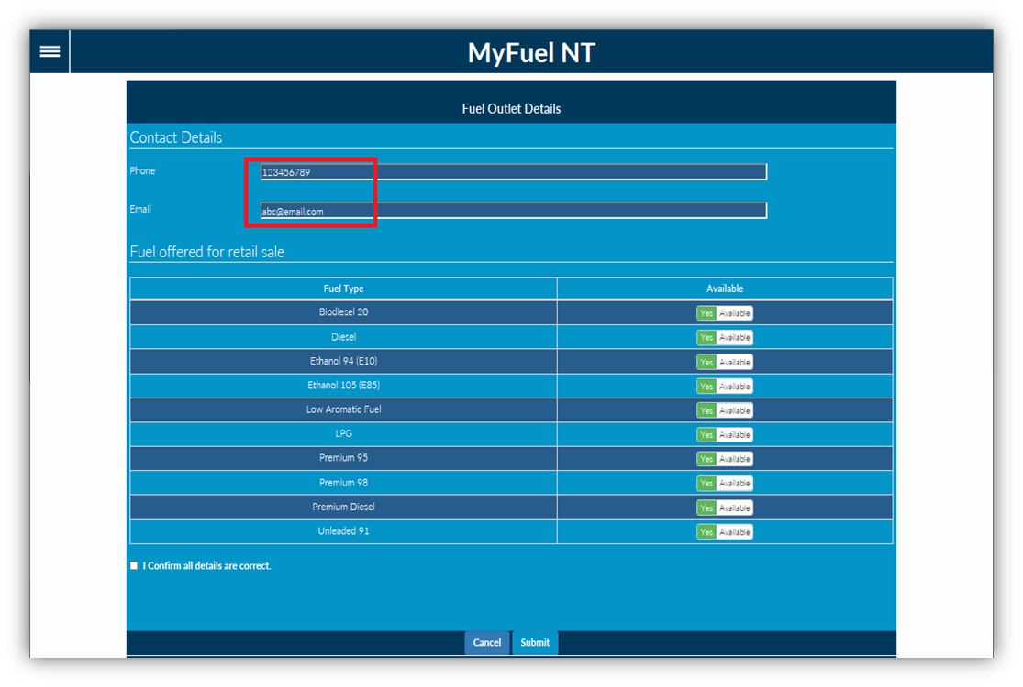

The Fuel Outlet Details page displays the Contact Details of the fuel outlet.

The fuel outlet’s Phone number and Email address can be modified here if needed.

A list of fuel types that are available for retail sale on an ongoing basis are also displayed.

Step 8
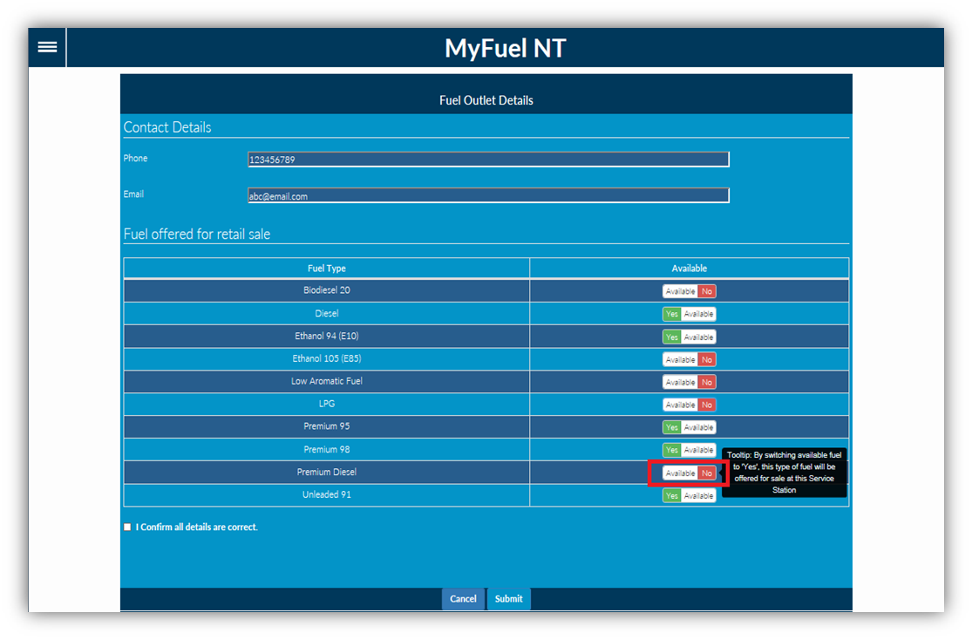

Availability of individual fuel types can be turned on or off here. For example, turned ON when you commence selling a fuel type not previously listed when you registered for MyFuel NT;

OR

turned OFF when a fuel type is removed from retail sale PERMANENTLY. To turn ON a fuel type set the availability to ‘Yes Available’.
To turn OFF a fuel type set the availability to ‘Available No’.

IMPORTANT: Fuel types set to ‘Available No’ will be removed from your service station listing on the MyFuel NT website and will not appear on the fuel types listed on the Submit Fuel Price page.

To set a fuel type as TEMPORARILY unavailable refer to the Submit Fuel Price training module.

STEP 9

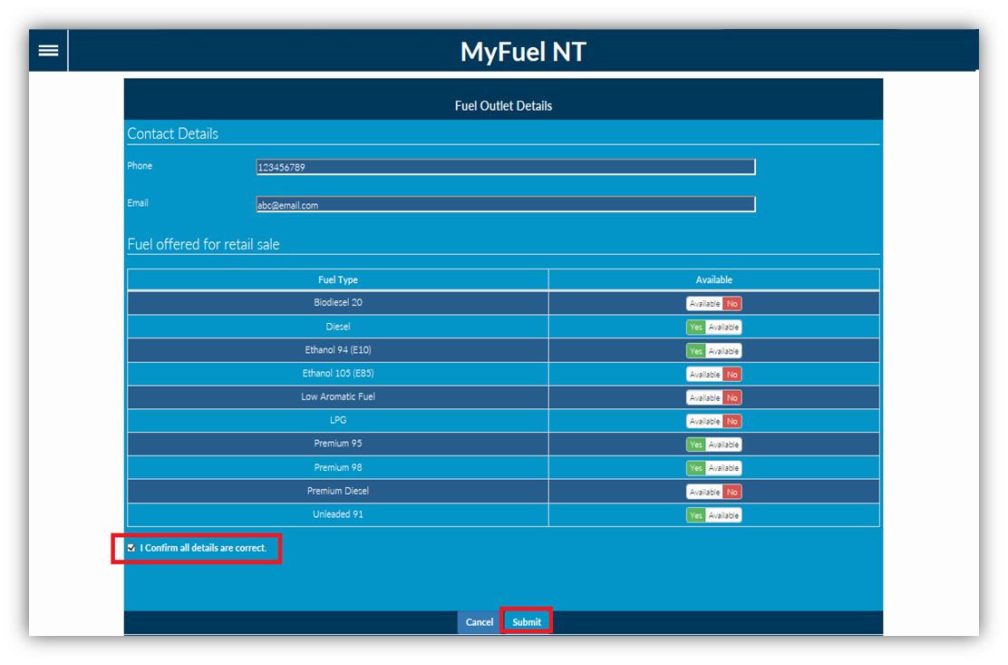
1
2

- Once all updates are completed, click on the checkbox ‘I Confirm all details are correct’; then

- Click on the ‘Submit’ button.

Step 10

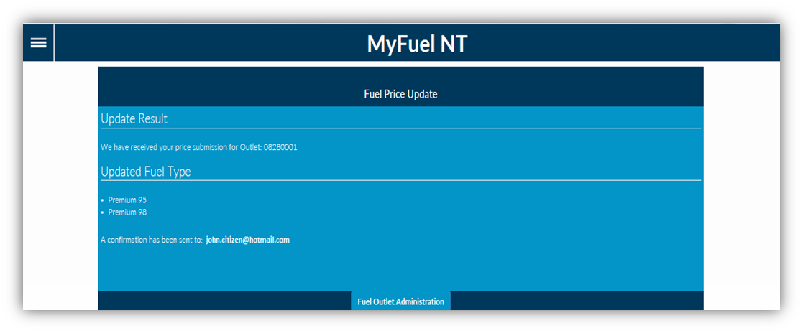

A confirmation page containing all the details that were updated will be displayed. An email notification will be sent to your registered email address.
Click on the ‘Fuel Outlet Administration’ button to return to the Fuel Outlet Administration Page.

