SUBMIT FUEL PRICE

PURPOSE:

This procedure is a step by step guide on how to update fuel prices or identify which fuel types are unavailable.

AUDIENCE:

All fuel outlet Managers and Operators who are registered in the MyFuel NT system.

STEP 1
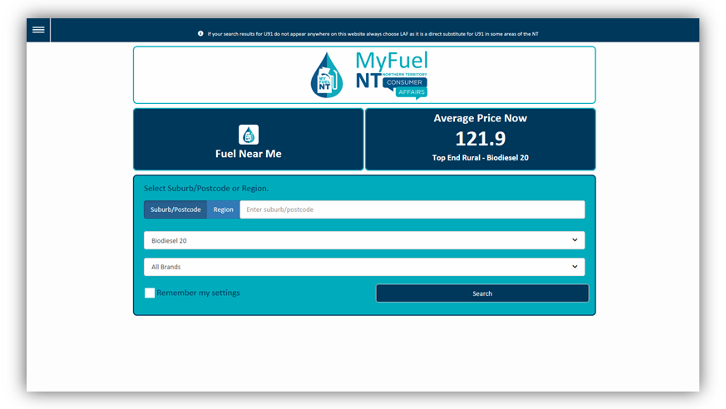

Go to the MyFuel NT website at https://myfuelnt.nt.gov.au.

The MyFuel NT home page is displayed.

STEP 2
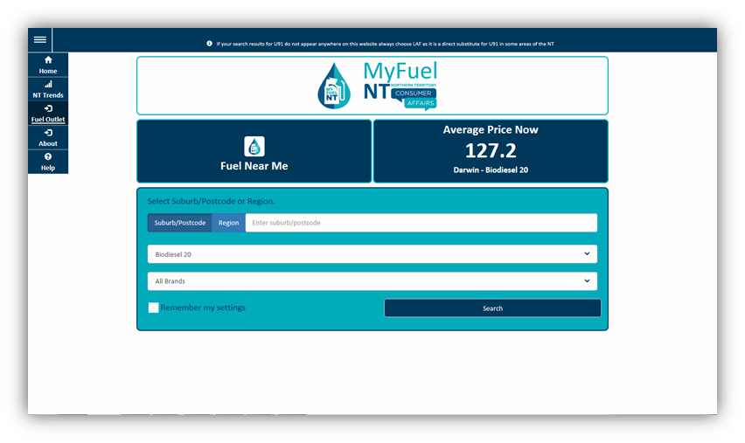

Navigate to the top left of the screen click the main menu and a drop down menu will appear, select ‘Fuel Outlet’.

Step 3
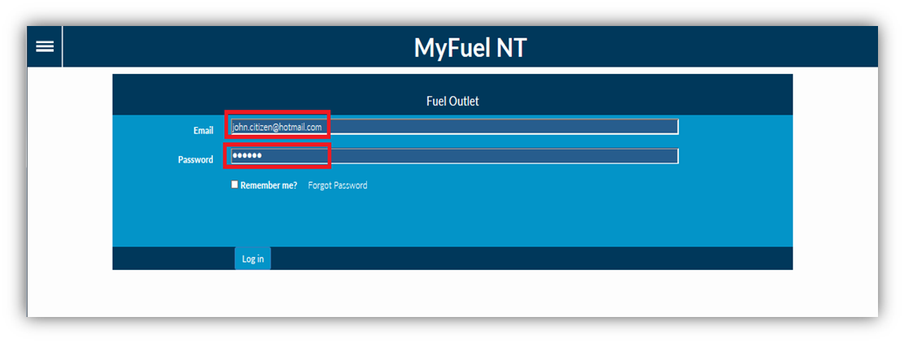
Enter your email address in the ‘Email’ field. Enter your password in the ‘Password’ field.
Check the ‘Remember me?’ checkbox if you prefer your details to be stored for your next login. Click on the ‘Log in’ button.

Step 4
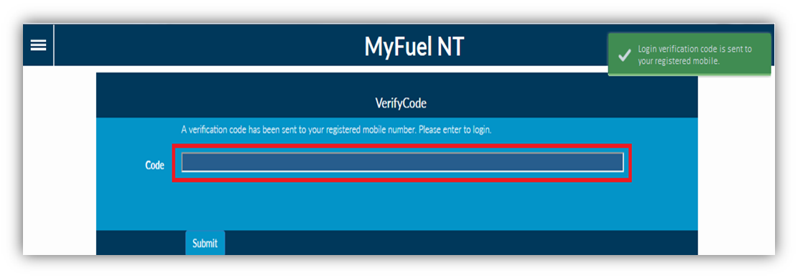

The Verification Code page is displayed.

The verification code will be sent to your registered mobile number. *
Enter the verification code in the ‘Code’ field. Click on the ‘Submit’ button.

- If you do not have a mobile telephone, you will need to contact NT Consumer Affairs for assistance on telephone number: 1800 019 319 or 08 8999 1999

Step 5

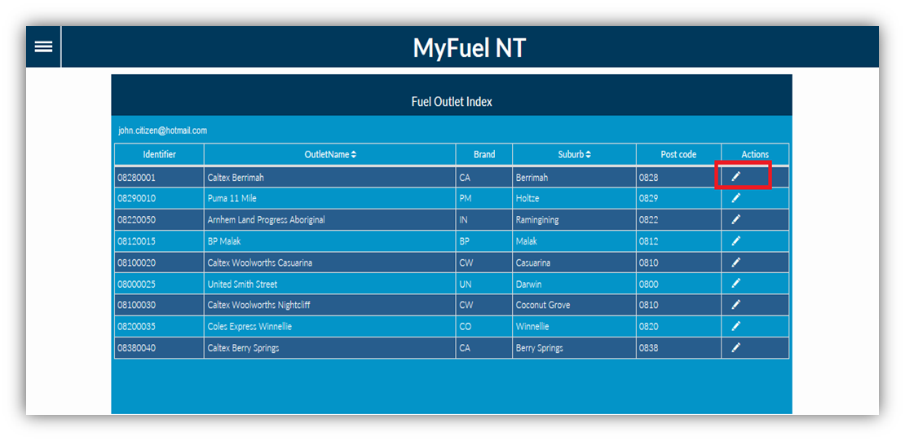

You will be presented with the Fuel Outlet Index page.

All service stations that you manage or are an operator at, will appear on the list. Click on the ‘Edit Fuel Outlet’ button in the Actions column.

Step 6

The Fuel Outlet Administration page will be displayed.

Managers are presented with the following options:

  - Submit Fuel Price
  - Price History
  - Fuel Outlet Details
  - Manage Staff
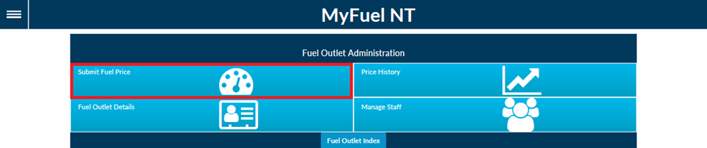

Operators are presented with the following options:

  - Submit Fuel Price
  - Price History
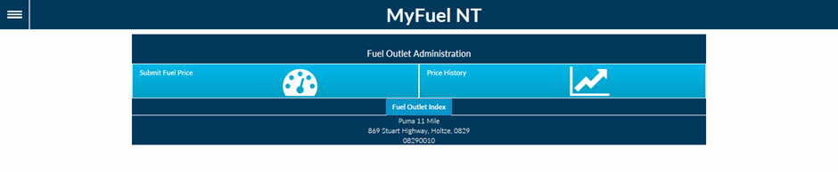
Both Managers and Operators should select ‘Submit Fuel Price’.

STEP 7

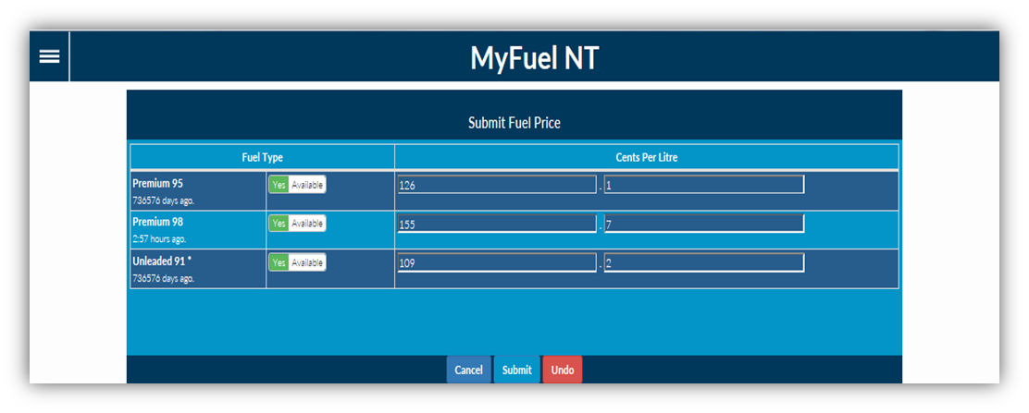
You will be presented with the Submit Fuel Price page.

This will only display fuel types that are marked ‘Yes Available’ on the Fuel Outlet Details page (refer Update Fuel Outlet Details training module).

Step 8
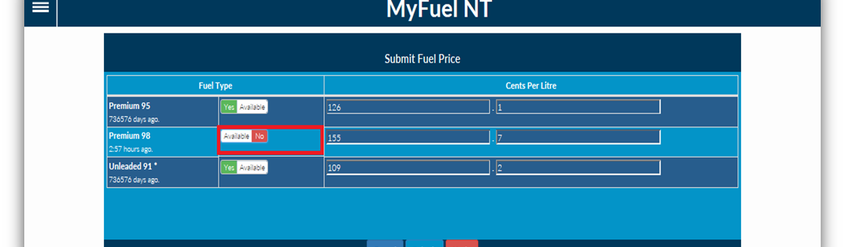

This Fuel Type section allows you to set the availability of individual fuel types listed for retail sale. Turn the fuel type on or off by clicking on the ‘Yes Available’ or ‘Available No’ toggle.
Set the fuel type to ‘Available No’ if the particular fuel is temporarily unavailable for retail sale, eg out of stock.

NOTE: Particular fuel types set as ‘Available No’ will appear as “n/a” on your service station listing on the MyFuel NT website.

IMPORTANT: To set a fuel type as PERMANENTLY unavailable refer to the Update Fuel Outlet Details
training module

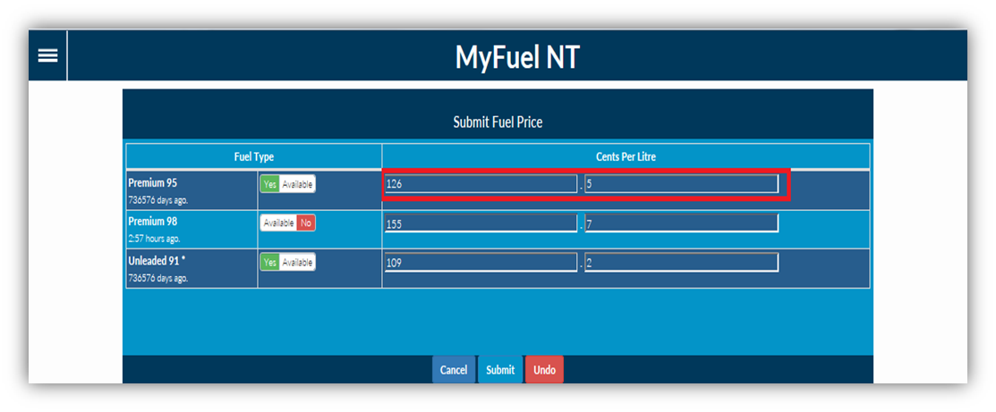
STEP 9

The ‘Cents Per Litre’ section shows the existing price of each fuel type. There are two separate fields to display decimal value.

You can update the fuel price by replacing the existing price with the latest price.

Once you click in the Cents Per Litre field the existing price can be deleted by clicking the ‘x’ which appears on the right of that field.

Enter the latest fuel price in the first field. Then the post decimal amount in the second field.

.
126
5

Selecting ‘Undo’ will reset all changes made.

Step 10

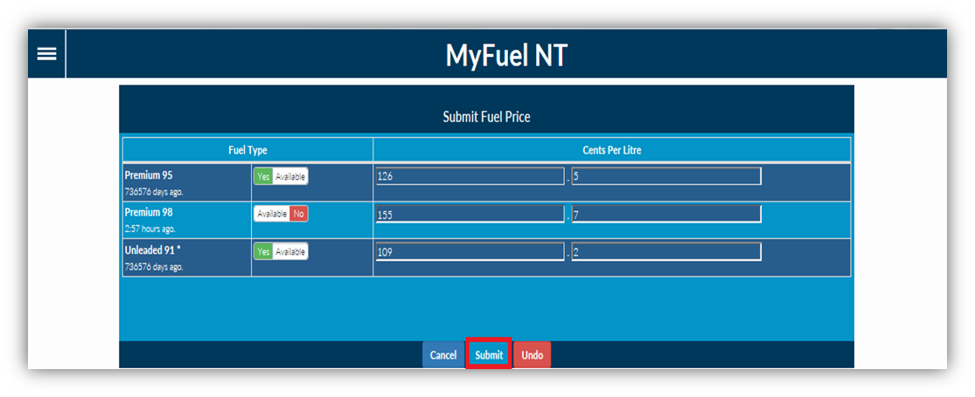
Click on the ‘Submit’ button once all required updates have been made.

Step 11

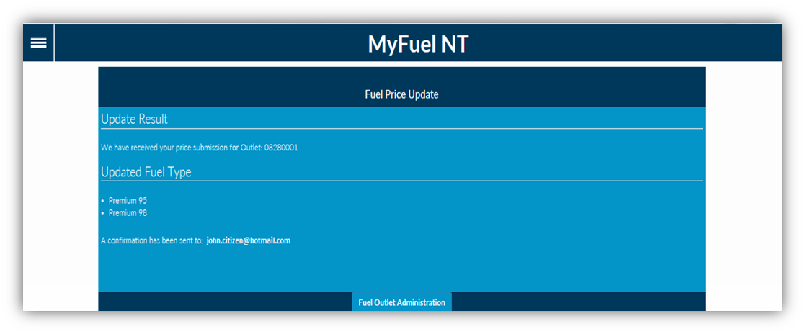

A confirmation page containing all the details that were updated will be displayed. An email notification will be sent to your registered email address.
Click on the ‘Fuel Outlet Administration’ button to return to the Fuel Outlet Administration Page.

