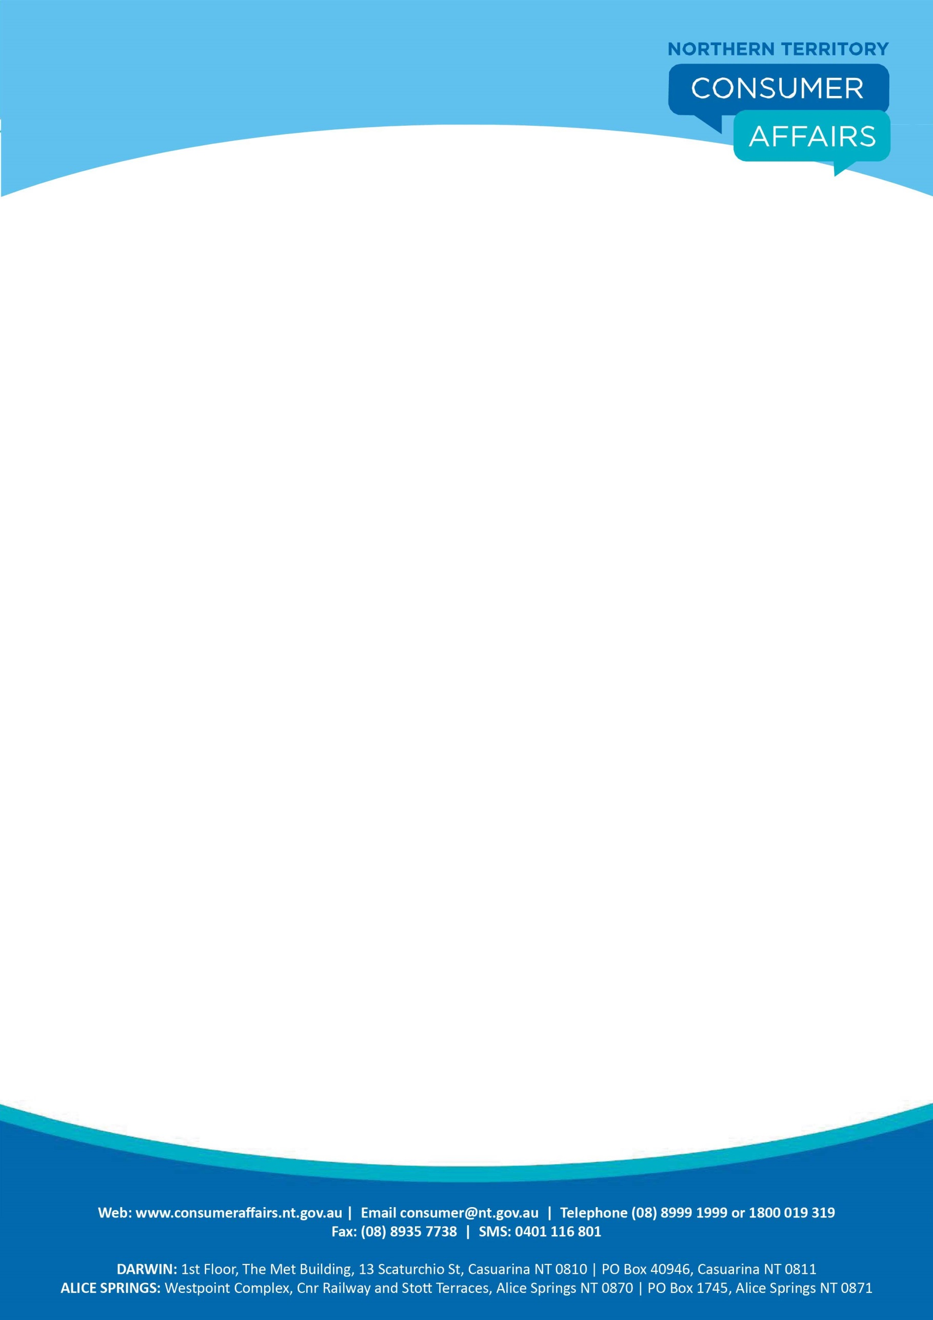

**FACTSHEET**

## EGG LABELLING

The Commonwealth Government has introduced an Information Standard under the Australian Consumer Law (ACL) for all egg producers that prescribes their obligations when promoting or selling free range eggs. The new Information Standard applies from 26 April 2018. The new standard will also inform consumers and the public more generally about free range egg claims which will enable the public to have confidence and make informed choices when buying free range eggs.

## How consumer laws apply

The ACL places an obligation on traders not to mislead consumers in promoting their goods and services therefore any claims that eggs are “free range” means they must come from hens that a reasonable consumer would consider are produced in a free range environment.

This fact sheet has been produced to clarify the requirements for making free range egg claims in the marketplace and to provide further certainty for consumers when they make purchasing decisions.

## What is required when using the term “free range”?

The Information Standard prescribes the following requirements to apply in the production of eggs if the term “free range” is applied to the labelling or promotion of those eggs.

* Eggs are laid by hens that had meaningful and regular access to an outdoor range during daylight hours across the laying cycle.
* Hens were subject to stocking density of 10,000 hens or less per hectare.

The requirements for the labelling of eggs produced as free range are:

* The stocking density must be prominently displayed on the packaging.

The requirements for the display of eggs produced as free range if they are not packaged are:

* The display sign must use the term “free range” prominently.
* The stocking density must be prominently displayed on the signage.

## When are free range egg claims made?

A free range claim is made under the new standard if producers:

* Use the words ‘free range’ on packaging or in any advertising or promotion.



A producer is in breach of the information standard if the requirements for using the term “free range” is not complied with. It is clearly misleading to claim eggs are free range when the hens that laid the eggs have never left the shed or are significantly restricted from doing so.

## Who can I contact for more information?

For more information refer to the [ACL (Free Range Egg Labelling) Information Standard 2017](https://www.legislation.gov.au/Details/F2017L00474)