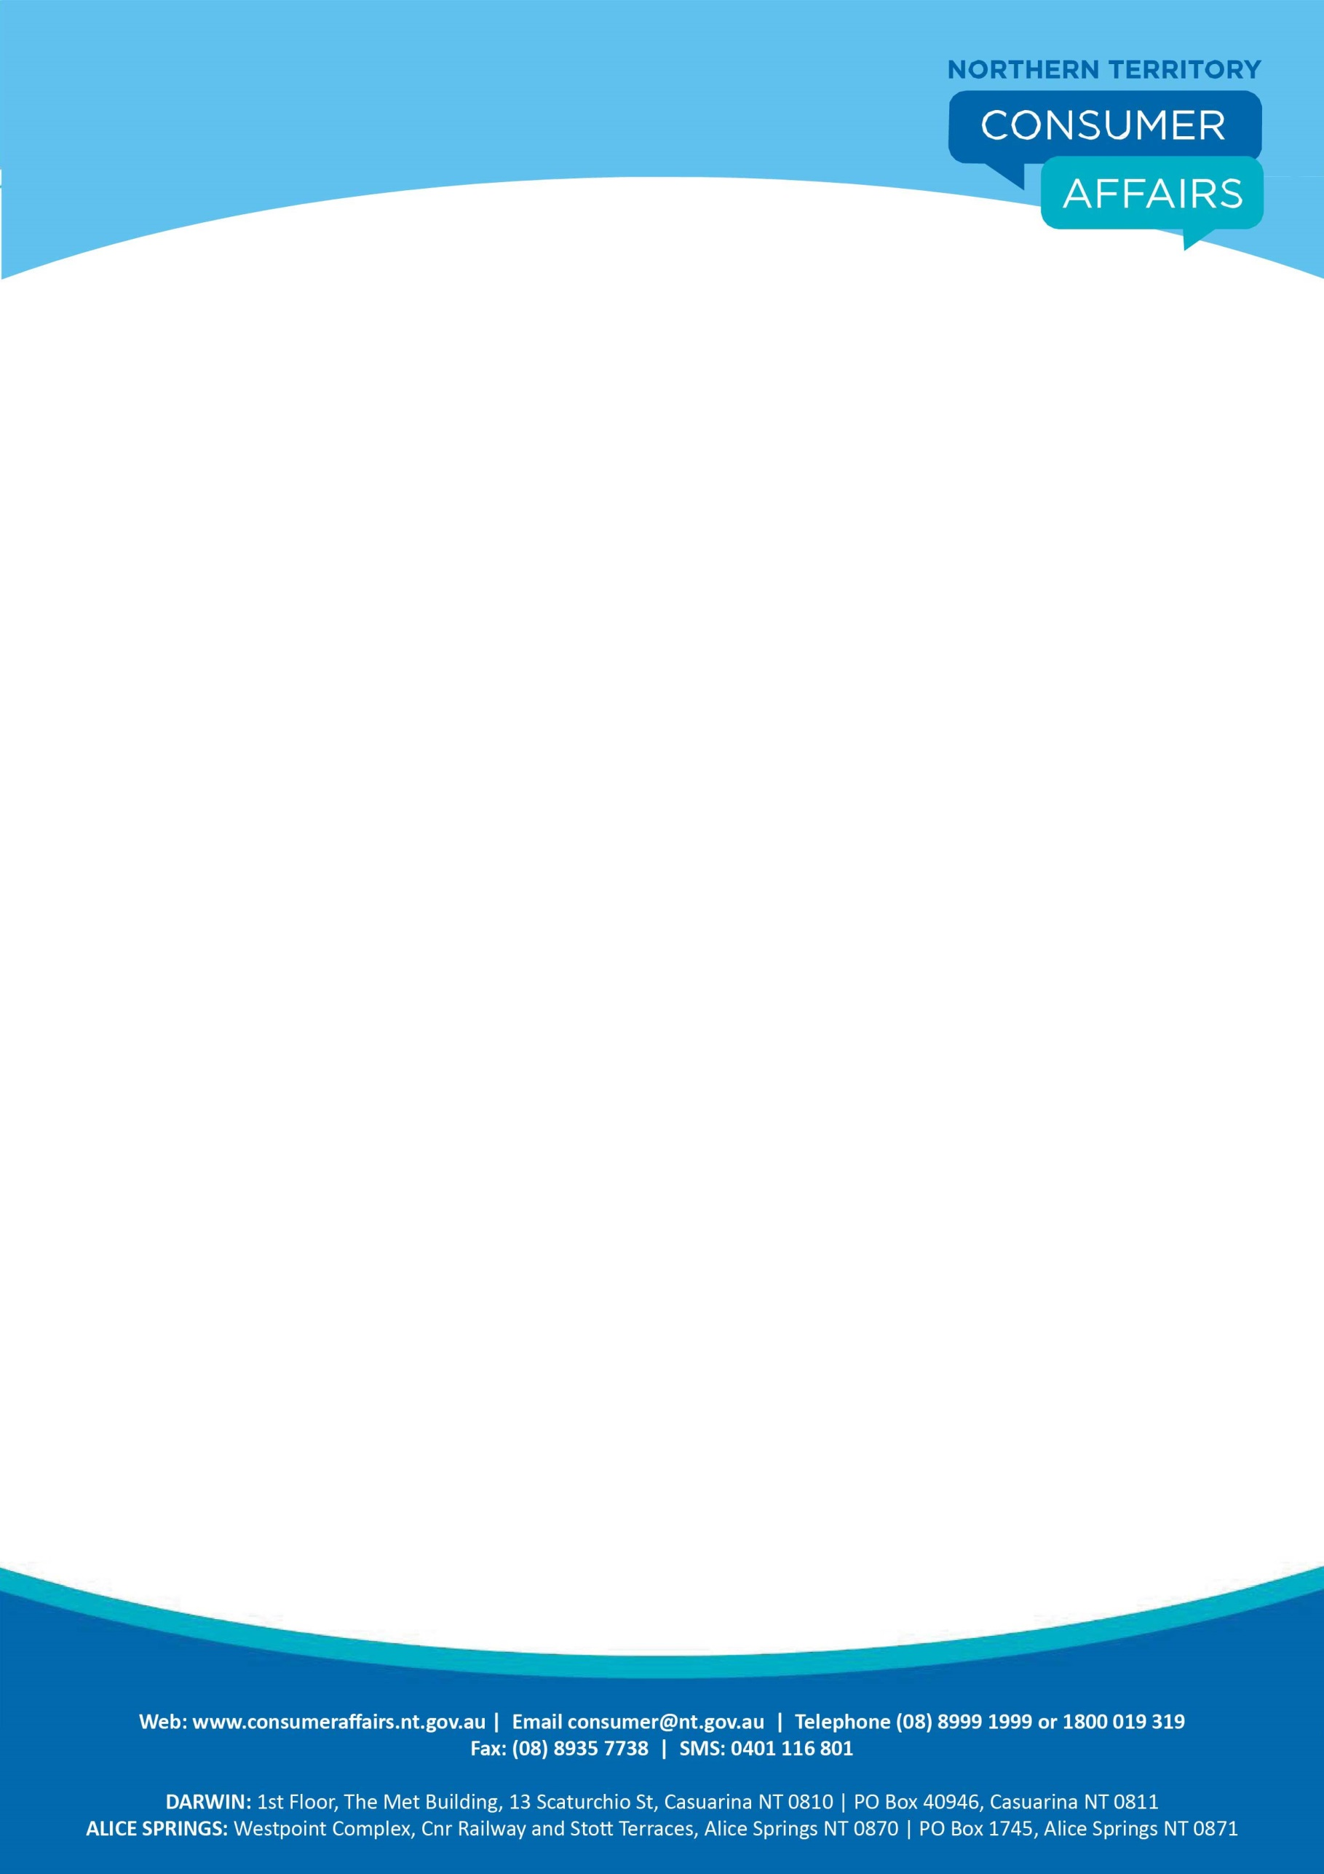

**FACTSHEET**

**PRICE SCANNING**

**Electronic price scanners are used in all major supermarkets, variety stores and hardware stores; and are becoming more prevalent in the stores of many smaller traders across the Northern Territory.**

There are many benefits to price scanning for the consumer, including the ability to instantly produce an itemised receipt of purchases. However, you should be careful to ensure the scanned price matches the price marked either on the shelf or on the item’s packaging.

**Voluntary code**

Some supermarkets are signatories to a voluntary code, developed in conjunction with the Australian Retailers Association, called the Code of Practice for Computerised Checkout Systems in Supermarkets.

In the Northern Territory, Woolworths is the only signatory to this Code.

The Code was developed to ensure the interests of consumers are protected when scanning systems are used, and encourages price-accuracy of checkout systems and shelf pricing procedures within supermarkets.

The Code applies to all items sold by the trader, except:

* Liquor products;
* Tobacco products;
* Items which do not have a barcode; or
* Items where the shelf price is $50 or greater.

Participating traders should provide clearly displayed shelf prices and provide information to consumers about the Code upon request.

**What if the item scans at a higher price?**

If an item scans at a higher price than is advertised on the shelf, you are entitled under the Code to receive the item free of charge.



If you are purchasing more than one of the item, you should receive the first item free of charge and the remaining items at the lower shelf price.

If an error does occur, you should bring the matter to the immediate attention of the staff member at the checkout or the store manager.

If you do not discover the overcharging until you have left the store, retain your receipt and bring the matter to the store manager’s attention as soon as possible.

**What happens when prices change?**

The Code requires that any price increases are to be changed on the shelf labels first and then entered into the store’s computer system.

Similarly, any decreases in price are to be first entered into the trader’s computer system, with the shelf prices to be changed once this has been done.

This system should ensure items are always scanned at the cheaper price.

**What if the trader is not a signatory to the code?**

If an error in price scanning occurs with a trader that is not a signatory to the Code, you should discuss the matter with the manager of the store.

Where a trader is found to be continually overcharging consumers at the checkout, Consumer Affairs may view such acts as misleading and deceptive, which is a breach of the Australian Consumer Law.

**Who do I complain to?**

If you are not satisfied with the outcome provided to you by the store manager, you can contact either:

Consumer Affairs

Phone: **1800 019 319**

OR

**The Retail Council:** Scanning Code Customer Service Hotline

Phone: **02 8249 4520**

More information can be found on the Retail Council’s website – <http://www.retailcouncil.com.au>